Smith Chart Homework 1 (22 Points )
(jas, Smith Chart HW1.docx, 5/04/2023)

Use units and clearly label answers using 3 or 4 significant digits where appropriate. Show your work so that if necessary partial credit can be awarded.
For the following homework it is recommended that you use the Interactive Smith Chart available at: Applied Electromagnetics 8E Textbook Website. The Interactive Modules, are located under Student Resources. Go to Chapter 2: Transmission Lines 2.6 – Interactive Smith Chart for this homework. You can also use a printed Smith Chart along with compass, pencil and ruler. A Smith Chart pdf is available in Canvas in the Course Specifics module if a printed copy is needed.

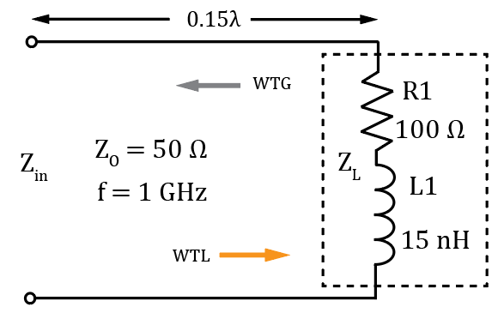
- For the adjacent circuit:

- Determine Z_{L} expressed in rectangular form, including units. (2 Points.)

Z_{L} = 100 + j94.25 Ω (2 points.)

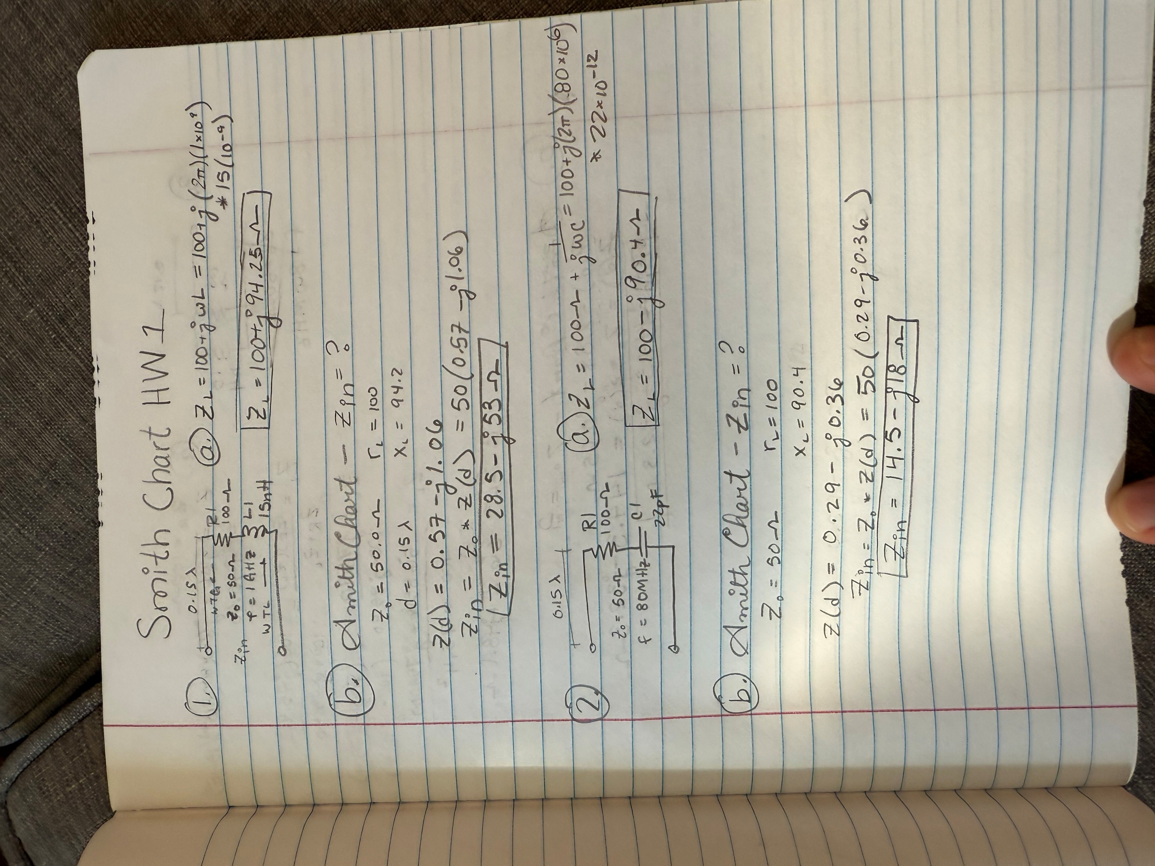

- Using a Smith Chart determine Z_{in} in rectangular form including units, for the above circuit using your Z_{L} value from part a. (Hint: Z_{in} should be between 25 - j50 Ω and 30 – j55 Ω.) (2 points.)

Z_{in} = 28.5 – j53 Ω (2 points.)

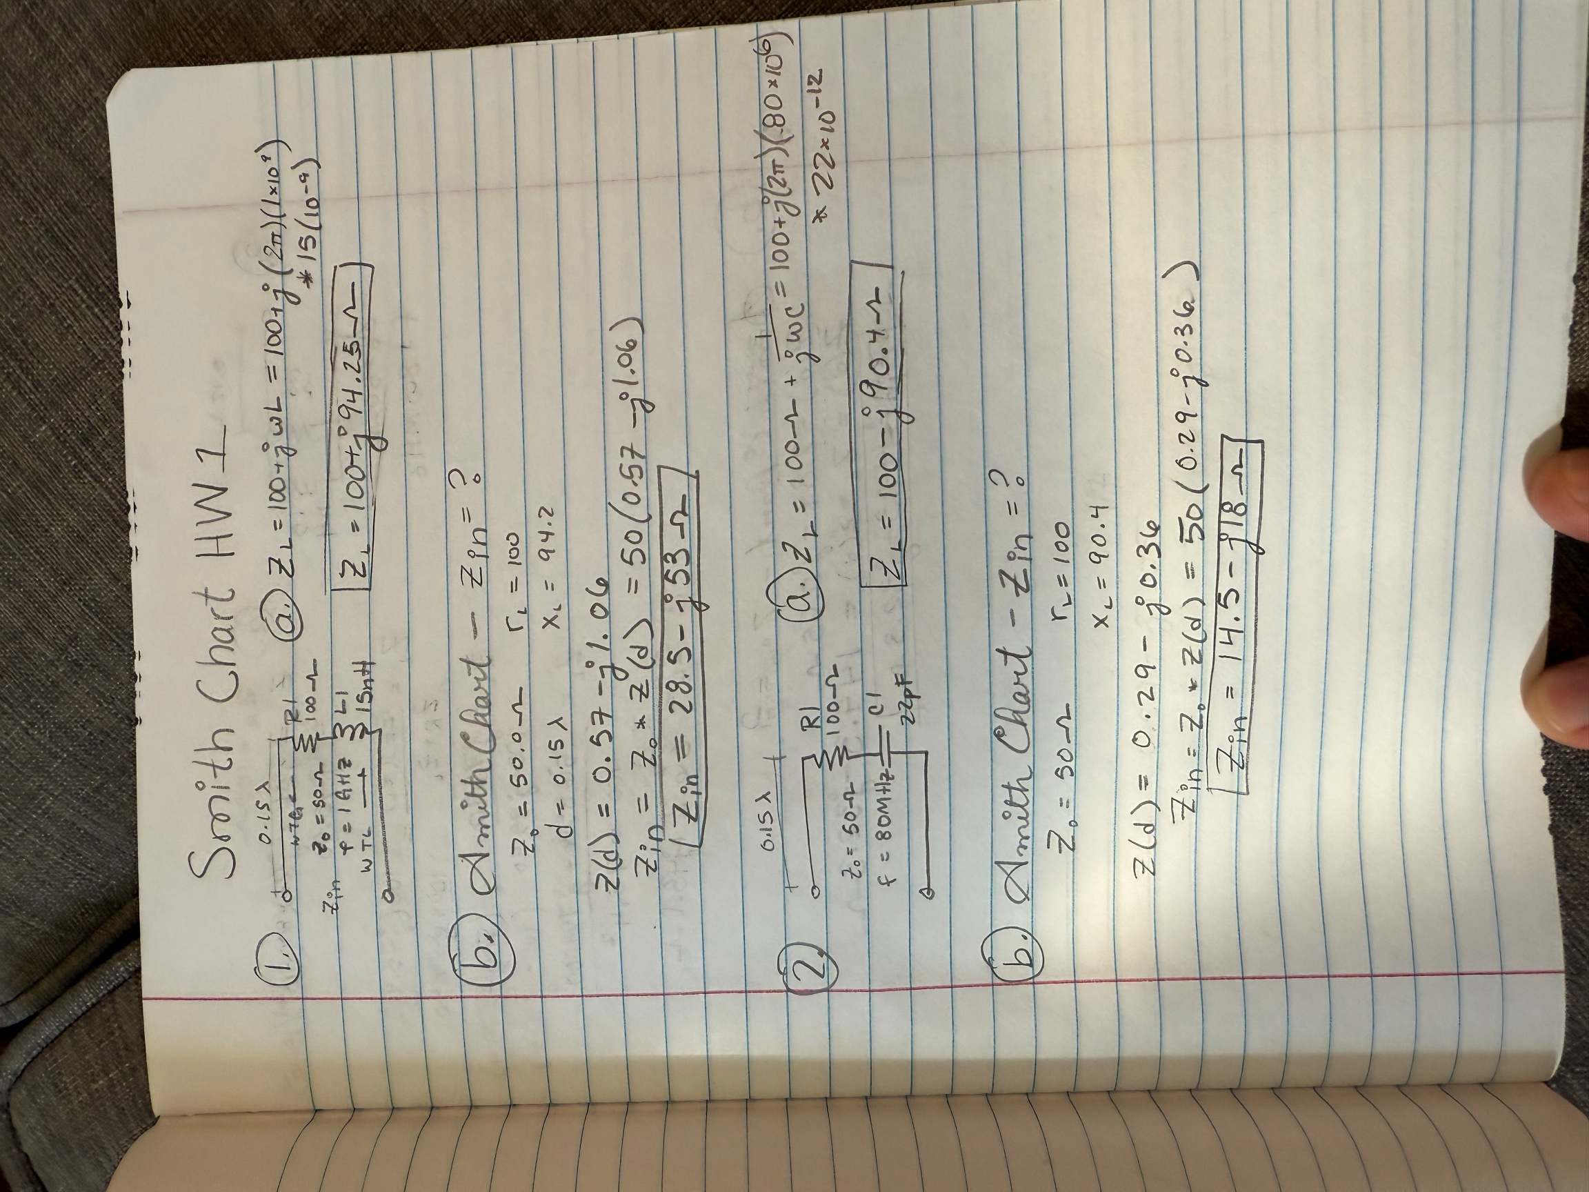

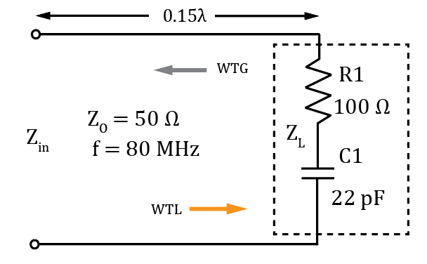
- For the adjacent circuit:

- Determine Z_{L} expressed in rectangular form, including units. (2 Points.)

Z_{L} = 100 – j90.4 Ω (2 points.)



- Using a Smith Chart determine Z_{in} in rectangular form including units, for the above circuit using your Z_{L} value from part a. (Hint: Z_{in} should be between 12 – j15 Ω and 15 – j20 Ω.) (2 points.)

Z_{in} = 14.5 – j18 Ω (2 points.)



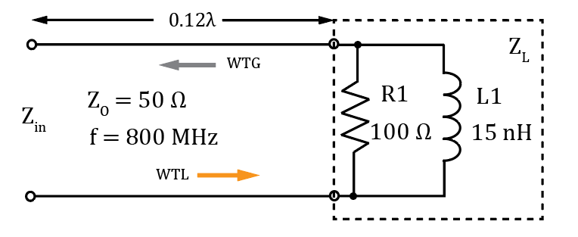
- For the adjacent circuit:

- Determine Z_{L} expressed in rectangular form, including units. (2 Points.)

Z_{L} = 36.2 + j48.1 Ω (2 points.)

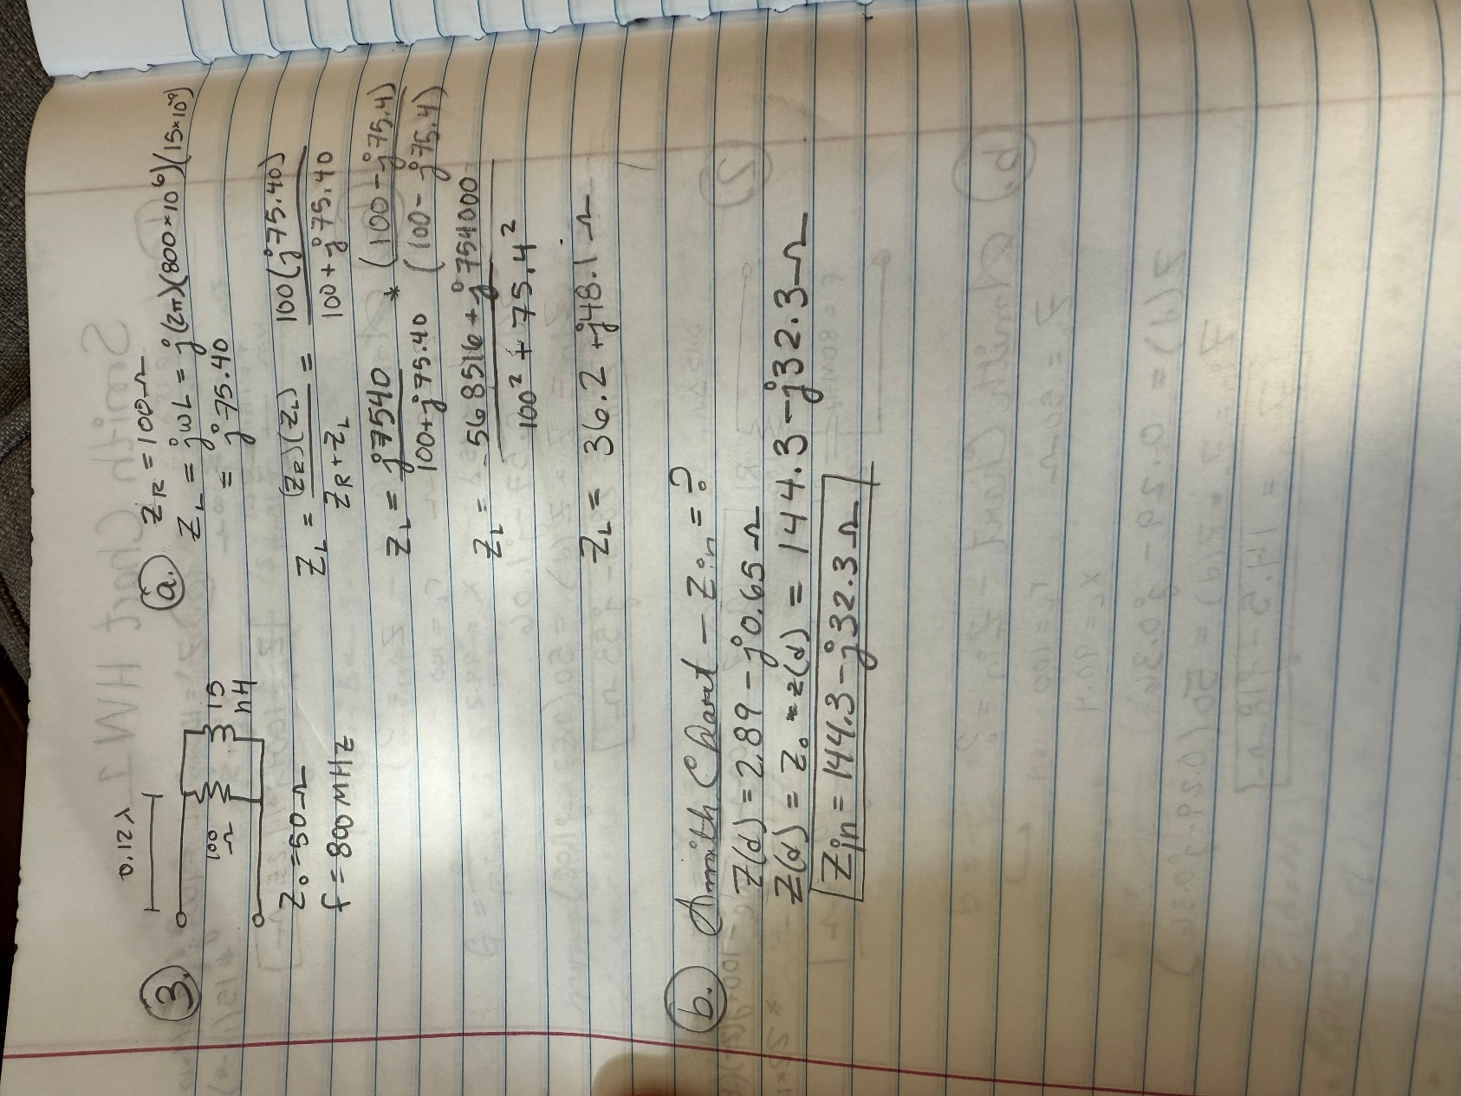

- Using a Smith Chart determine Z_{in} in rectangular form including units, for the above circuit using your Z_{L} value from part a. (Hint: Z_{in} should be between 140 – j28 Ω and 150 – j35 Ω.) (2 points.)

Z_{in} = 144.3 – j32.3 Ω (2 points.)
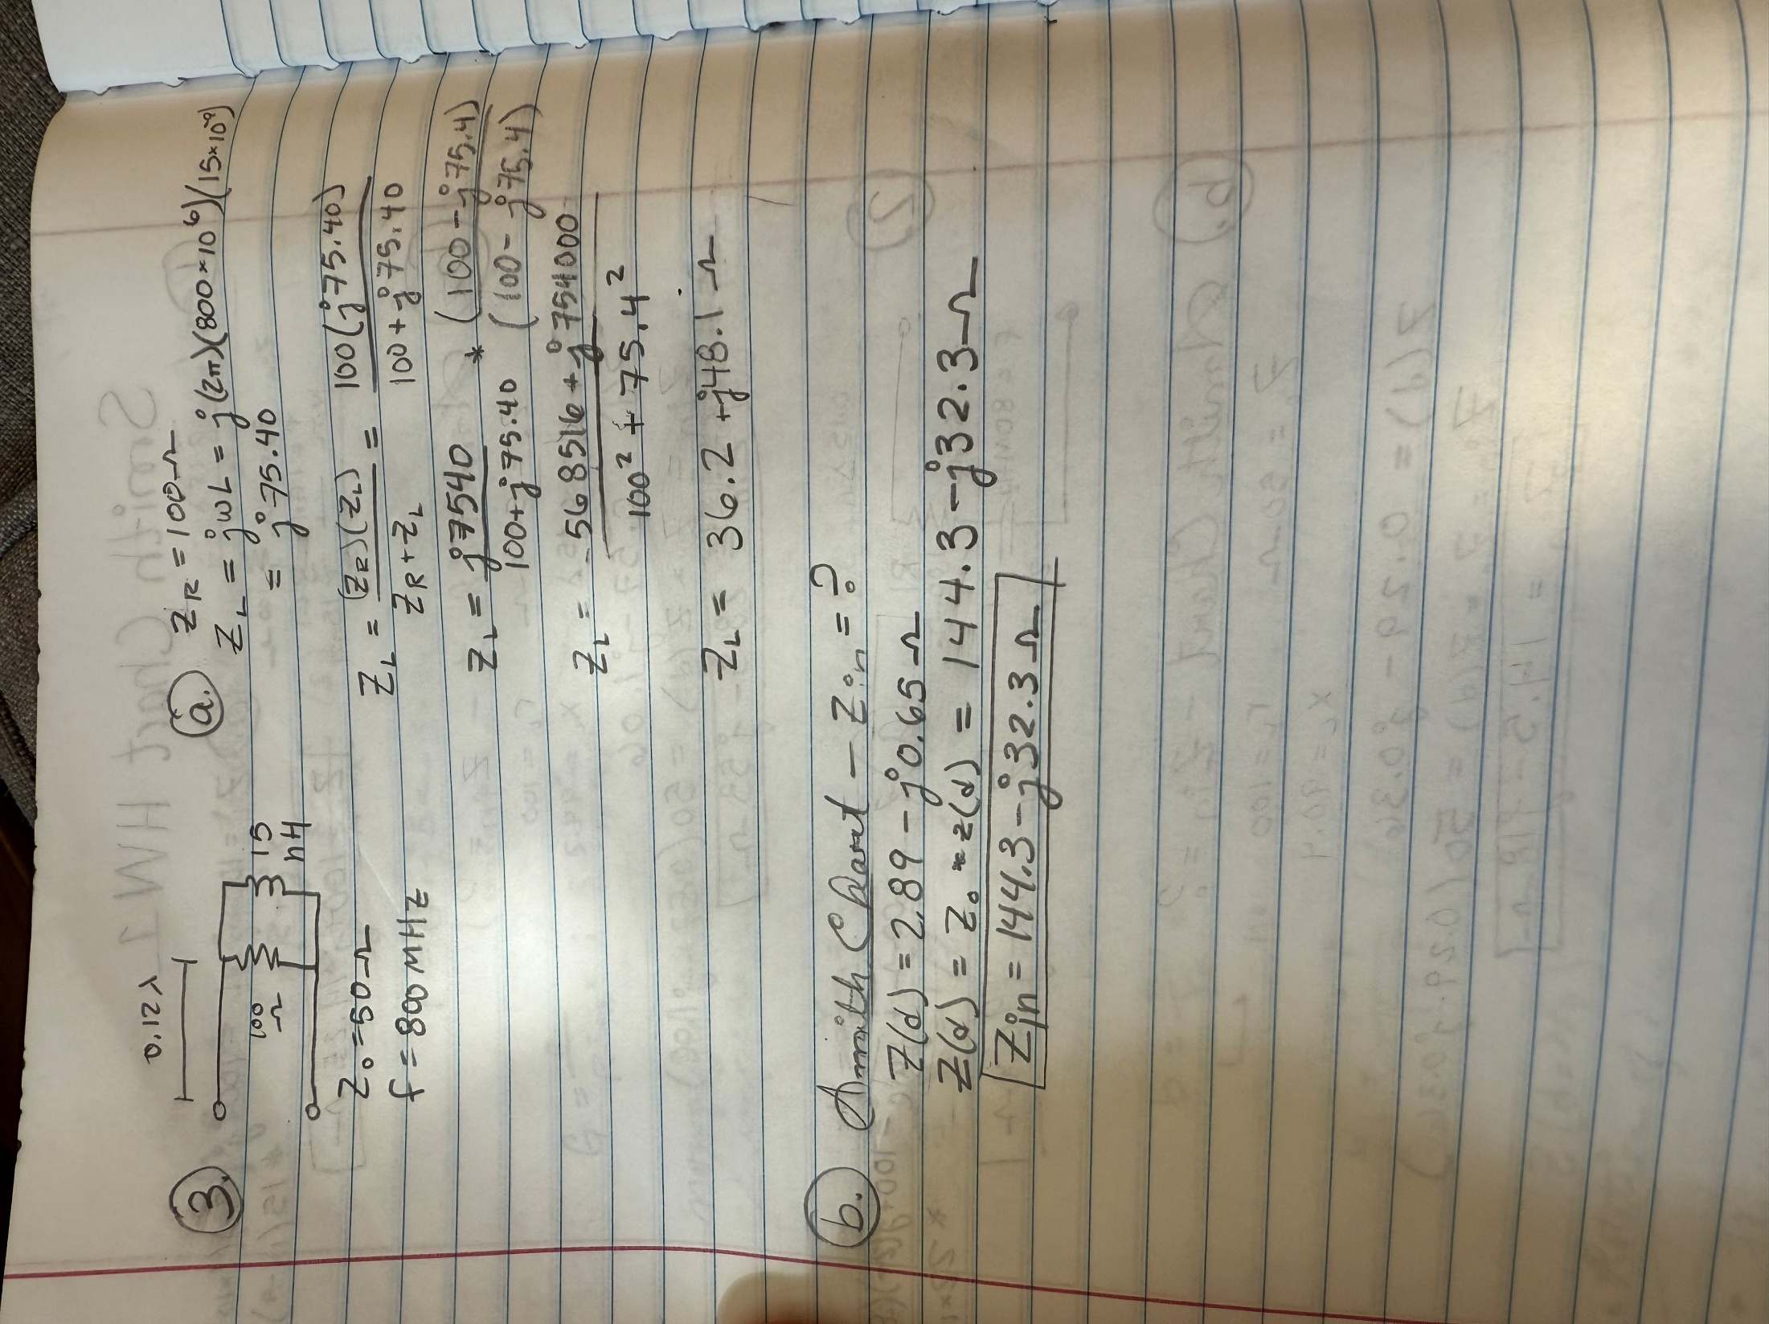

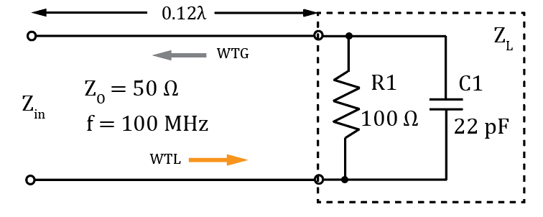
- For the adjacent circuit:

- Determine Z_{L} expressed in rectangular form, including units. (2 Points.)

Z_{L} = 34.3 – j47.5 Ω (2 points.)

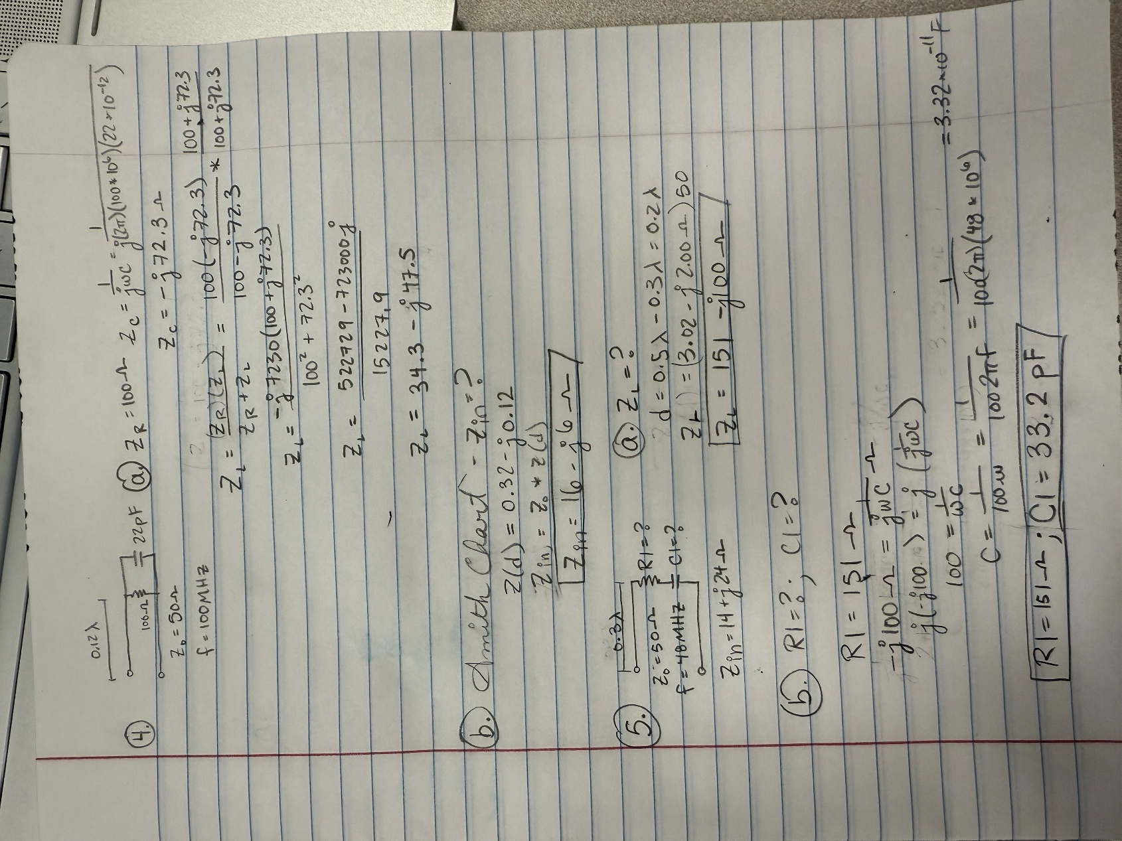

- Using a Smith Chart determine Z_{in} in rectangular form including units, for the above circuit using your Z_{L} value from part a. (Hint: Z_{in} should be between 12 – j3 Ω and 18 – j7 Ω.) (2 points.)

Z_{in} = 16 – j6 Ω (2 points.)

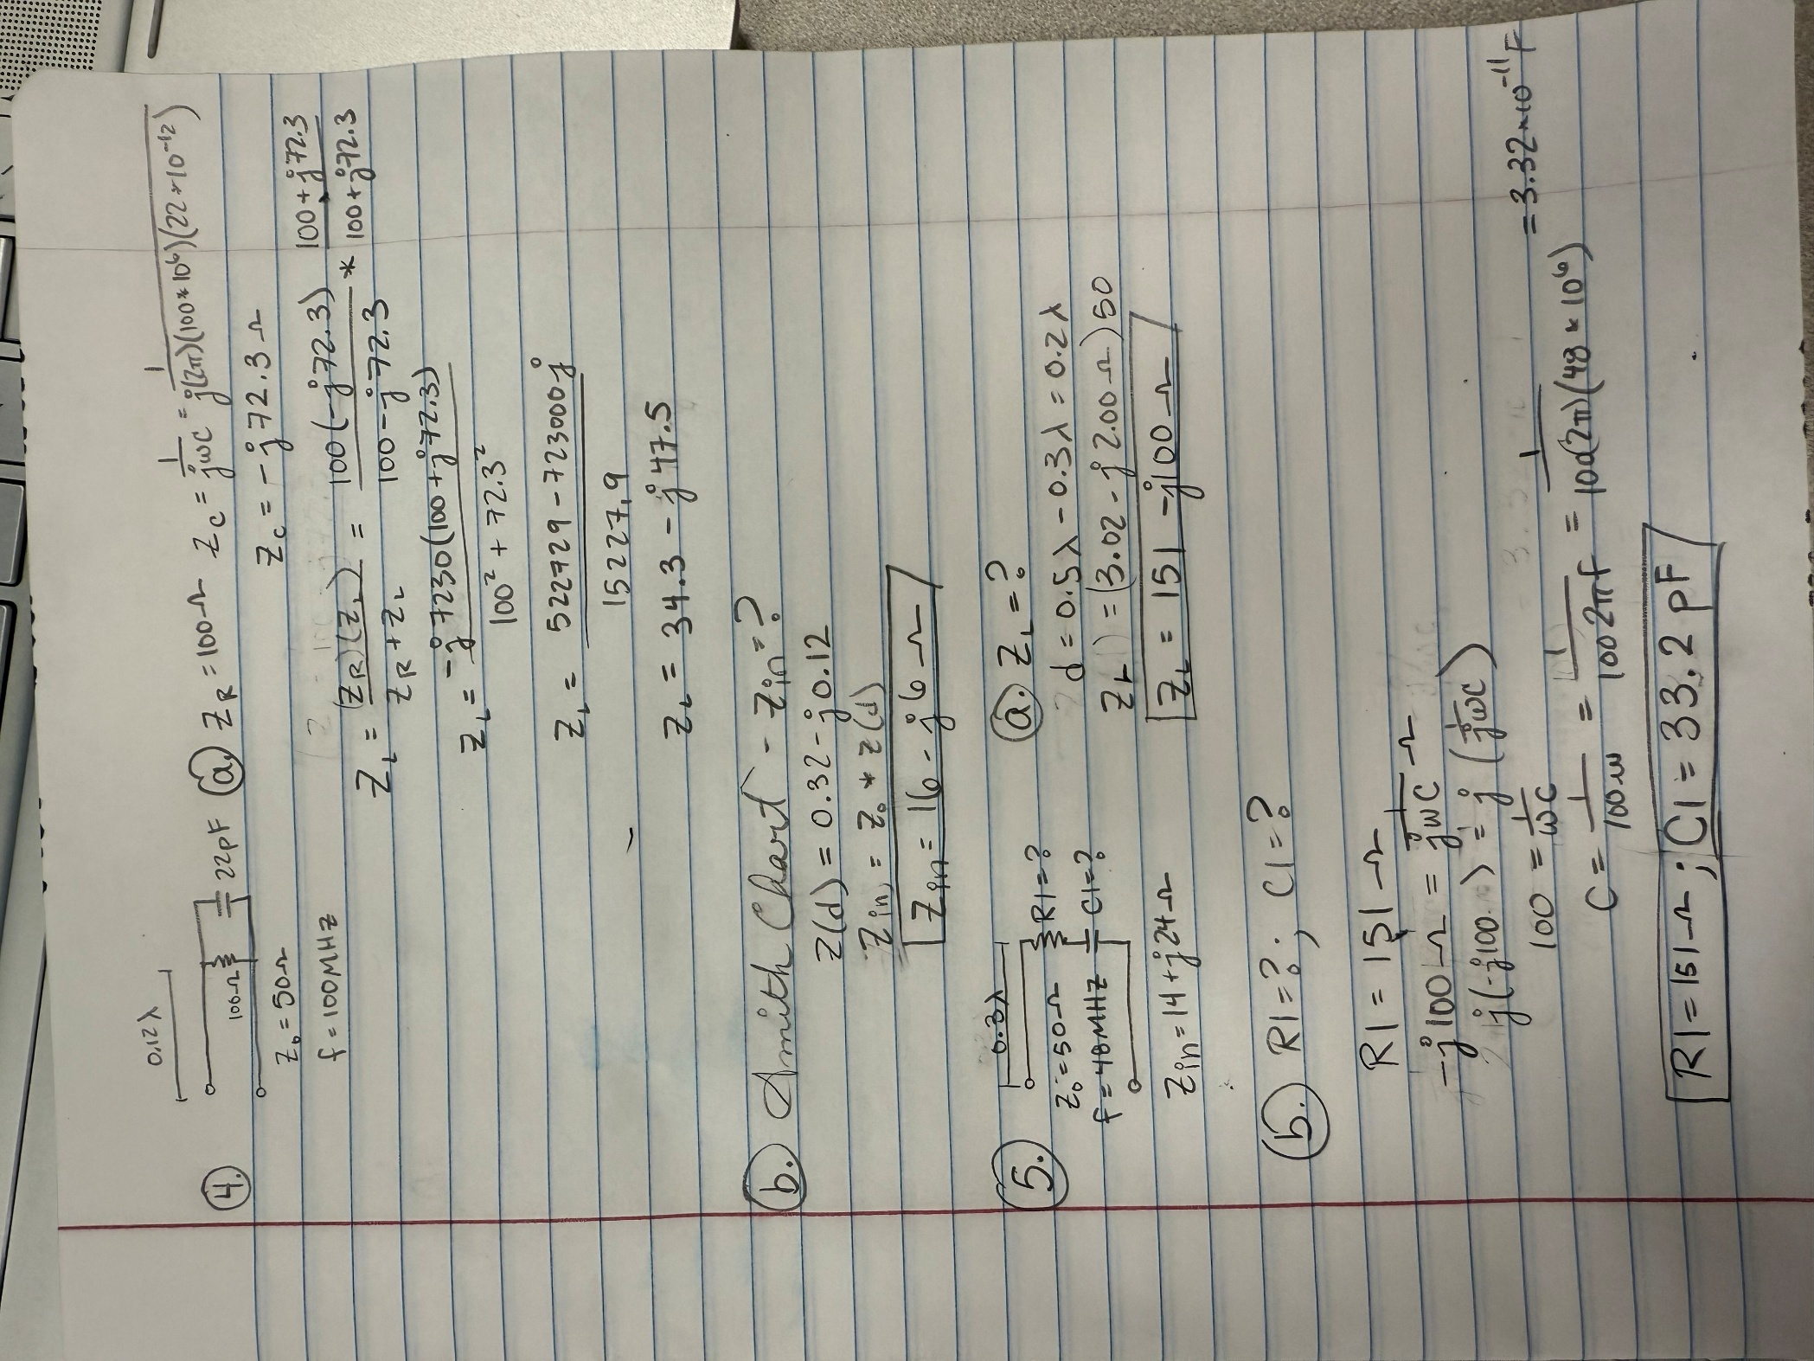

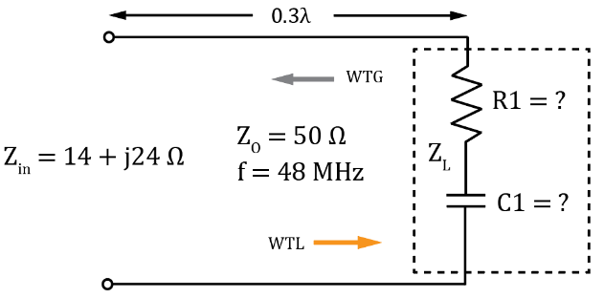
- For the adjacent circuit:

- Determine Z_{L} in rectangular form including units. (2 points.)

Z_{L} = 151 – j100 Ω

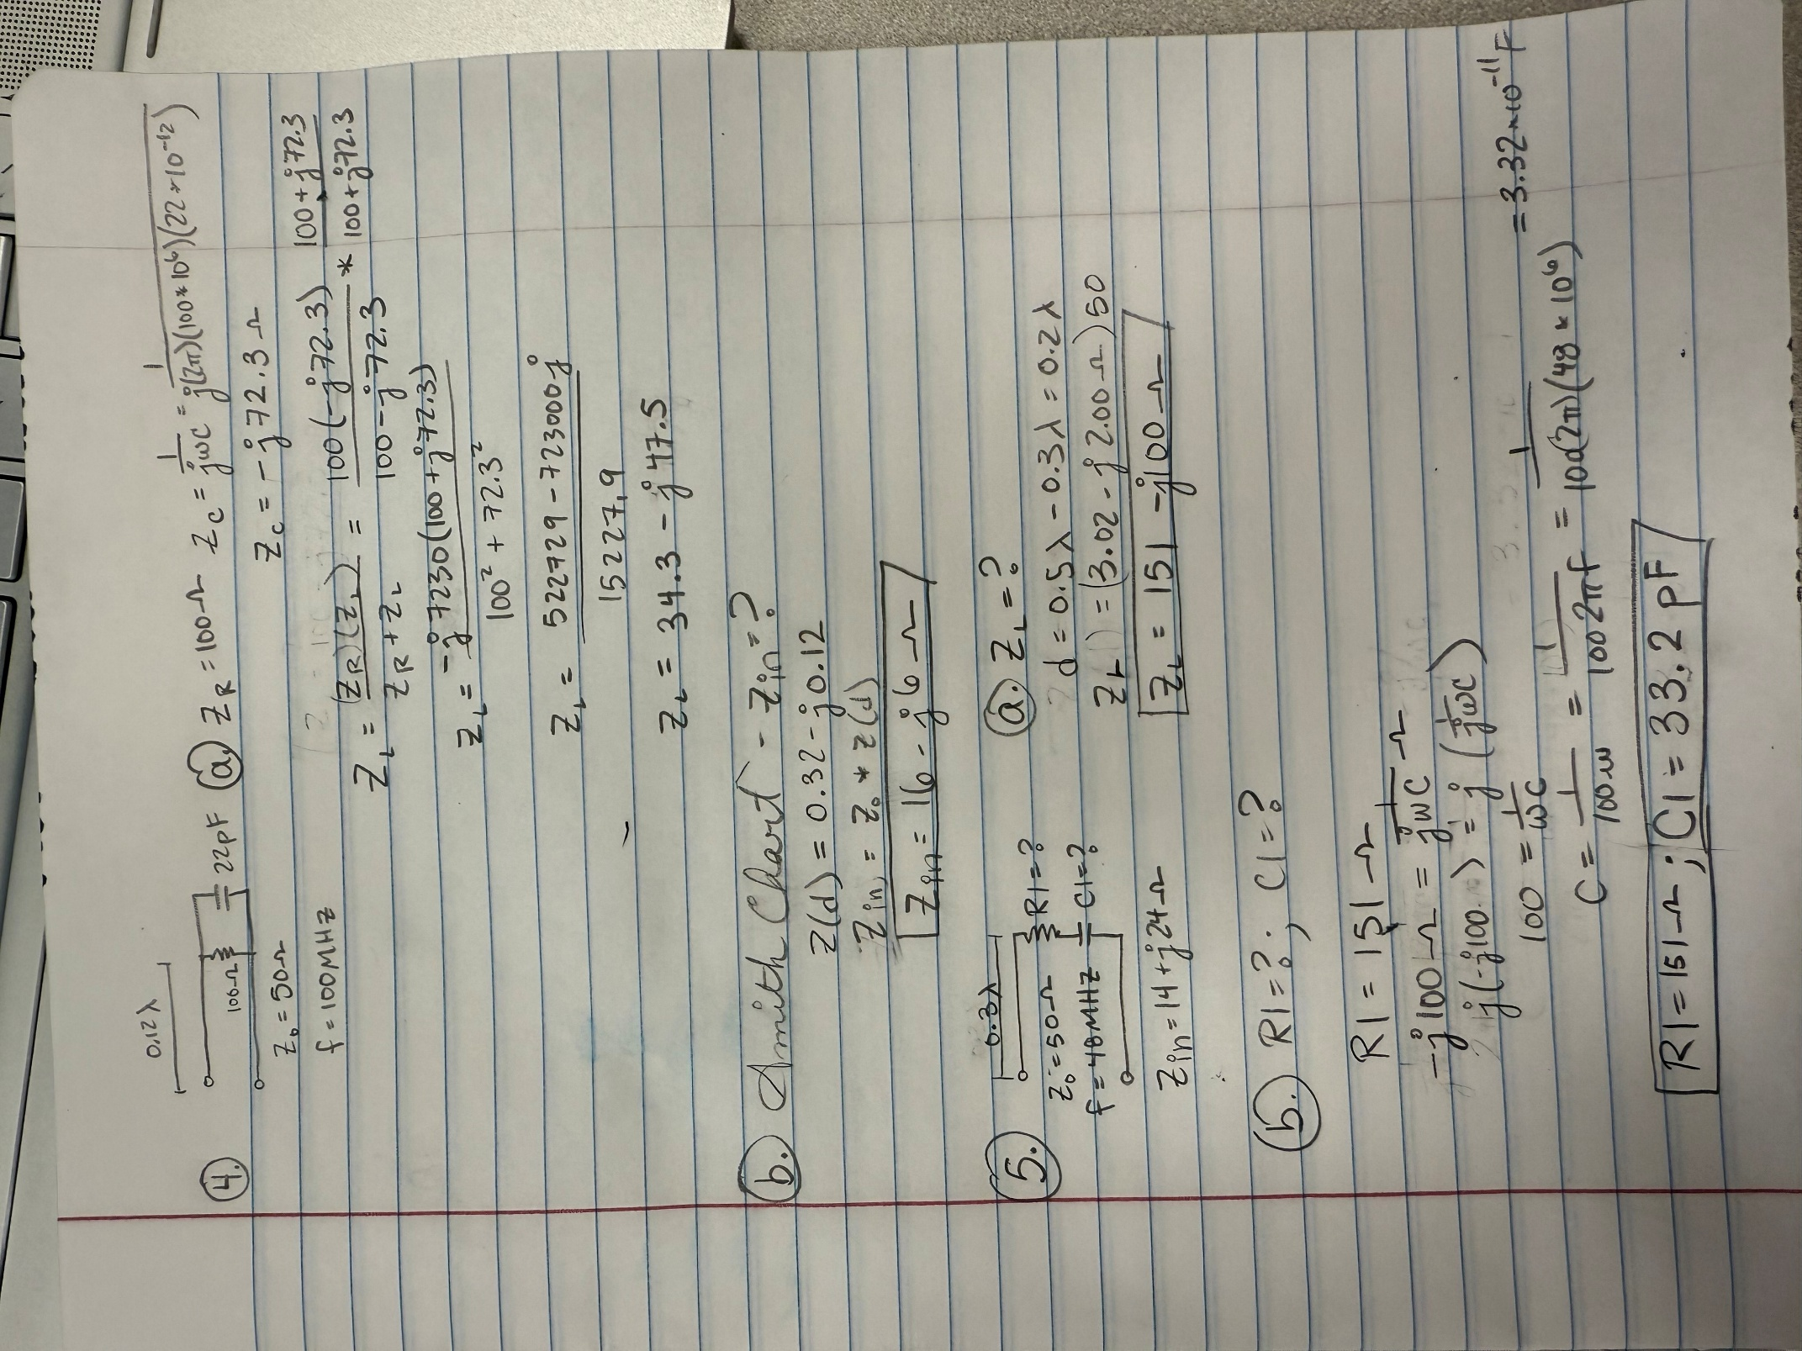

- Determine the values of both R1 and C1. (Hint: R1 should be between 140 and 160 Ω and C1 should be between 27 pf and 42 pf.)

R1 = 151 Ω (1 point.)

C1 = 33.2 pF (3 points.)

